Project Design Phase-II
Data Flow Diagram & User Stories

Date | 31 January 2025
Team ID | LTVIP2026TMIDS41308
Project Name | online payments fraud detection using machine learning
Maximum Marks | 4 Marks

Data Flow Diagrams:
A Data Flow Diagram (DFD) is a traditional visual representation of the information flows within a system. A neat and clear DFD can depict the right amount of the system requirement graphically. It shows how data enters and leaves the system, what changes the information, and where data is stored.
Example: DFD Level 0 (Industry Standard)
Example: (Simplified)
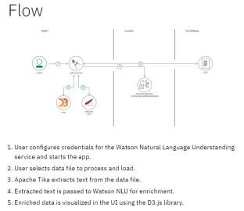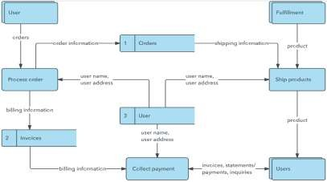

User Stories
Functional User Story
User Type User Story / Task Acceptance Criteria Priority Release
Requirement (Epic) Number
Customer As a user, I can access the home page of the Application loads index.html
Access Application USN-1 High Sprint-1
(Web User) fraud detection application successfully
Customer Enter Transaction As a user, I can enter transaction details like All input fields are visible and
USN-2 High Sprint-1
(Web User) Details step, type, amount, balances accept valid data types
Customer Encode Transaction As a user, when I select transaction type, the Selected type is transformed
USN-3 High Sprint-1
(Web User) Type system encodes it correctly using encoder.pkl without error
Customer As a user, I can click Predict to check whether System calls /predict route and
Predict Fraud USN-4 High Sprint-1
(Web User) a transaction is fraud or not displays prediction result
As a user, I can see whether the transaction is
Customer View Prediction Prediction text is displayed
USN-5 “Fraud Transaction” or “Not a Fraud High Sprint-1
(Web User) Result clearly on the same page
Transaction”
Customer As a user, I should receive an error if invalid System prevents submission or
Input Validation USN-6 Medium Sprint-2
(Web User) data is entered shows error message
Customer As a user, I can use the application on UI adjusts properly for different
Responsive UI USN-7 Medium Sprint-2
(Web User) desktop and mobile browsers screen sizes

